**Requirement Elicitation**

***Smart Course Planner for CGPA Optimization***

**1. Introduction**

The purpose of this document is to summarize the findings from a survey conducted among university students to understand the requirements for developing the *Smart Course Planner for CGPA Optimization*. This Webapplication aims to assist students in selecting optimal combinations of retakes and new enrollments of courses to maximize their CGPA.

**2. Survey Design**

A structured questionnaire was distributed to undergraduate students. The survey focused on:

* Current academic condition
* Course planning challenges
* Interest in a CGPA optimization tool
* Preferences in course selection assistance

**3. Survey Response Summary**

Here is a visual representation of the study of respondents in appropriate charts.

**What is your current year/level of study?**

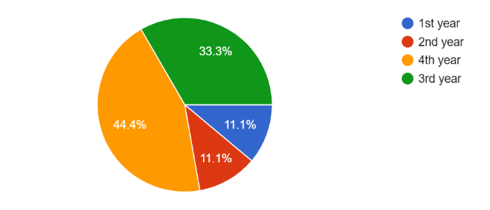

This chart shows that the majority of respondents are from the 3rd and 4th years (70% combined), indicating that the students closest to graduation are most concerned about optimizing their CGPA. Their insights are crucial in shaping the features and usability of the planner.

**Are you satisfied with your current CGPA?**

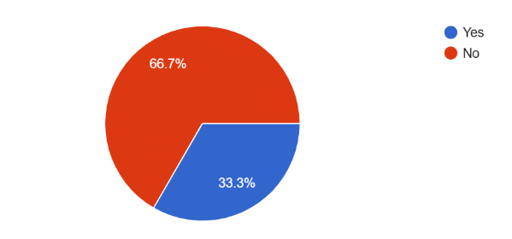

The graph reveals that 75% of students are not satisfied with their CGPA. This indicates a strong need for a system that helps students make strategic academic decisions to improve their GPA outcomes.

**How difficult is it for you to plan your retakes and new course enrollments?**

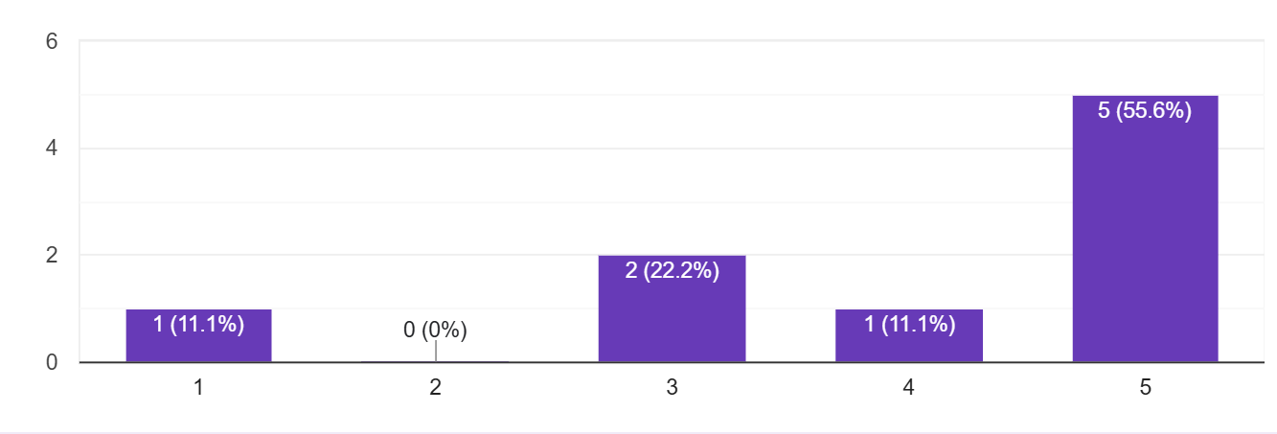

A large percentage (85%) of students find it either very or moderately difficult to plan course retakes or new enrollments. This supports the need for an intelligent decision-making tool like the Smart Course Planner.

**What are your main challenges when planning courses?**

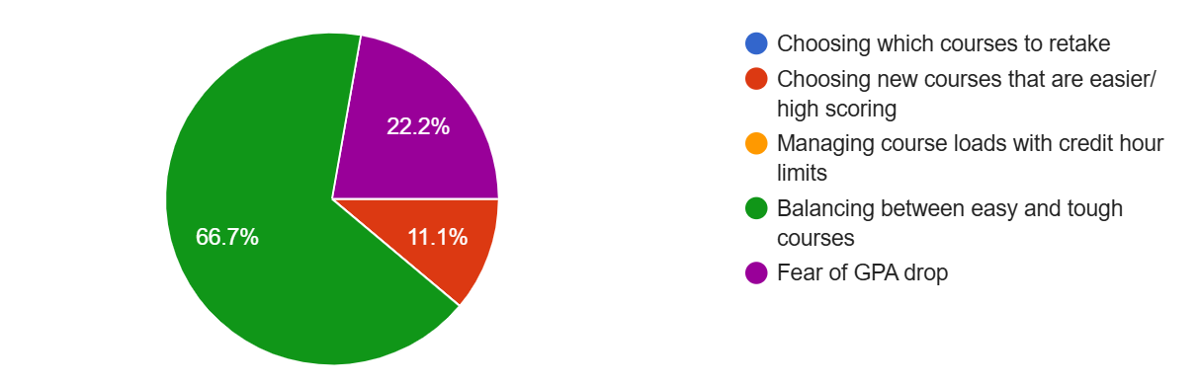

This visual summarizes the most common challenges faced by students. The recurring themes—such as lack of prioritization guidance, uncertainty about grade improvement, and high course load—highlight the pain points that the proposed system aims to solve.

**Do you wish you had a system to recommend the best course combination to maximize your CGPA?**

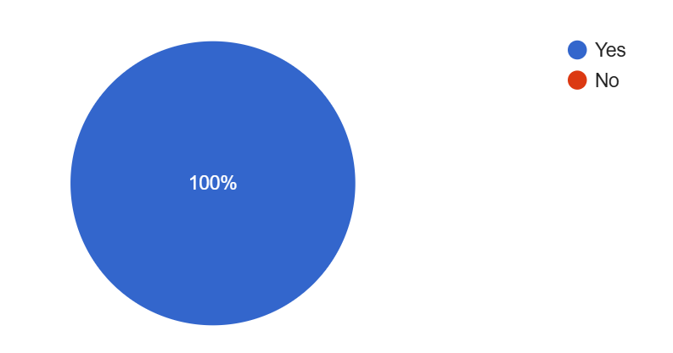

An overwhelming 100% of respondents expressed interest in a recommendation system. This validates the project's core idea and shows that most users are ready to adopt technology for academic planning.

**What factors do you consider when selecting your courses?**

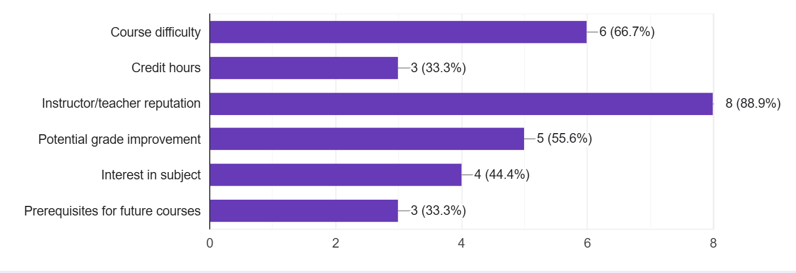

The chart displays the criteria students value when selecting courses. Credit hours, expected grades, and instructor reputation were the most important, guiding what variables the optimization algorithm should prioritize.

**How helpful would it be if a system predicted your possible CGPA based on selected courses?**

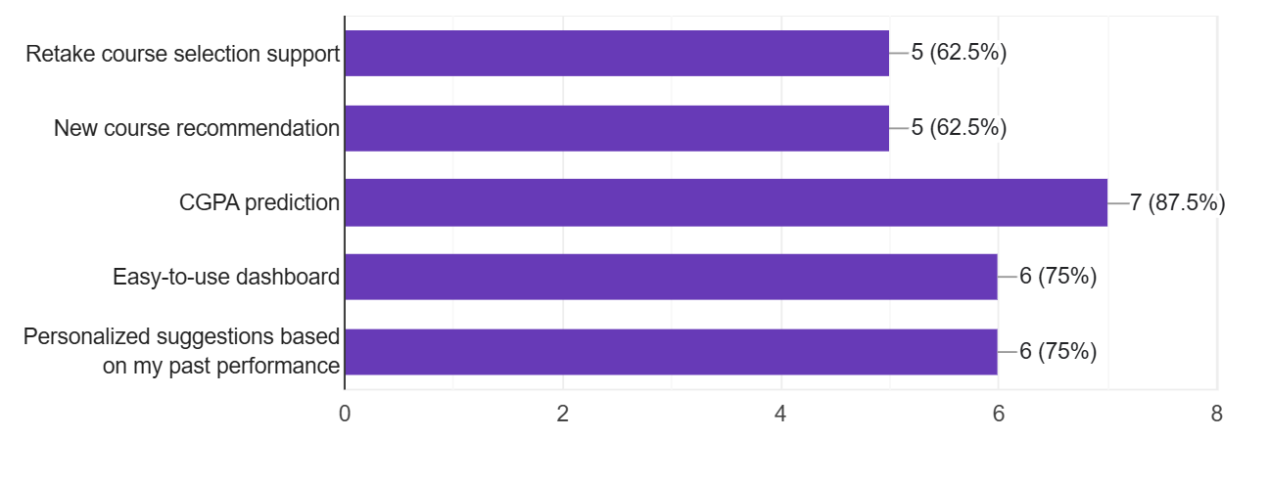

A total of 96% of students found a CGPA prediction feature helpful, proving that users want insight into the academic outcome of their course decisions. This affirms the value of integrating predictive analytics into the platform.

**Would you be interested in using a system that optimizes your CGPA with smart suggestions?**

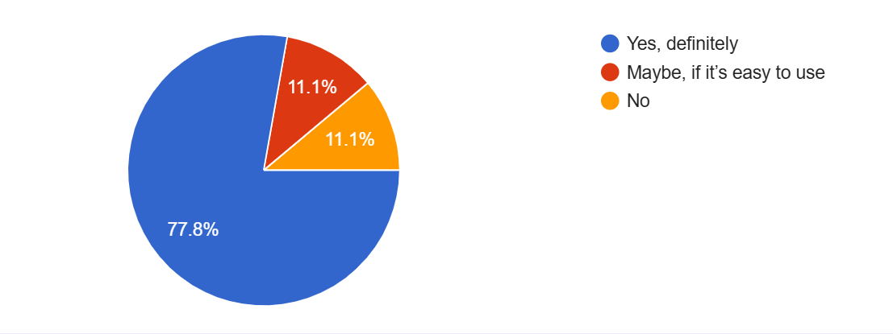

With 77.8% of students interested in using such a system, the data shows strong potential user adoption. This supports further development and investment in the tool as a meaningful academic aid.